 | Eukaryote | Prokaryote
Draw or paste an image from the computer for each type of cell | 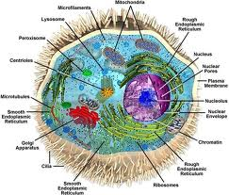 | 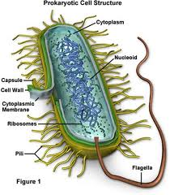
Size of cell (big/small) | Bigger | Smaller
Nucleus (present/absent) | True nucleus present | No true nucleus
Membrane-bound organelles (present/absent) | Present | Absent
Cytoplasm  -cytoskeleton (present/absent)  -cytoplasmic streaming (yes/no) | Cytoskeleton present  Cytoplasmic streaming present | No cytoskeleton  No cytoplasmic streaming
Ribosomes (big/small) | Bigger | Smaller
DNA arrangement (circular/linear) | Linear | Circular
Cell division (name type of division) | Mitosis | Binary fission
Examples (name examples for each type of cell) | Animas, plants, fungus, protists | Bacteria and archaebacteria
Name: Date:
Block:
Eukaryote vs. Prokaryotes

